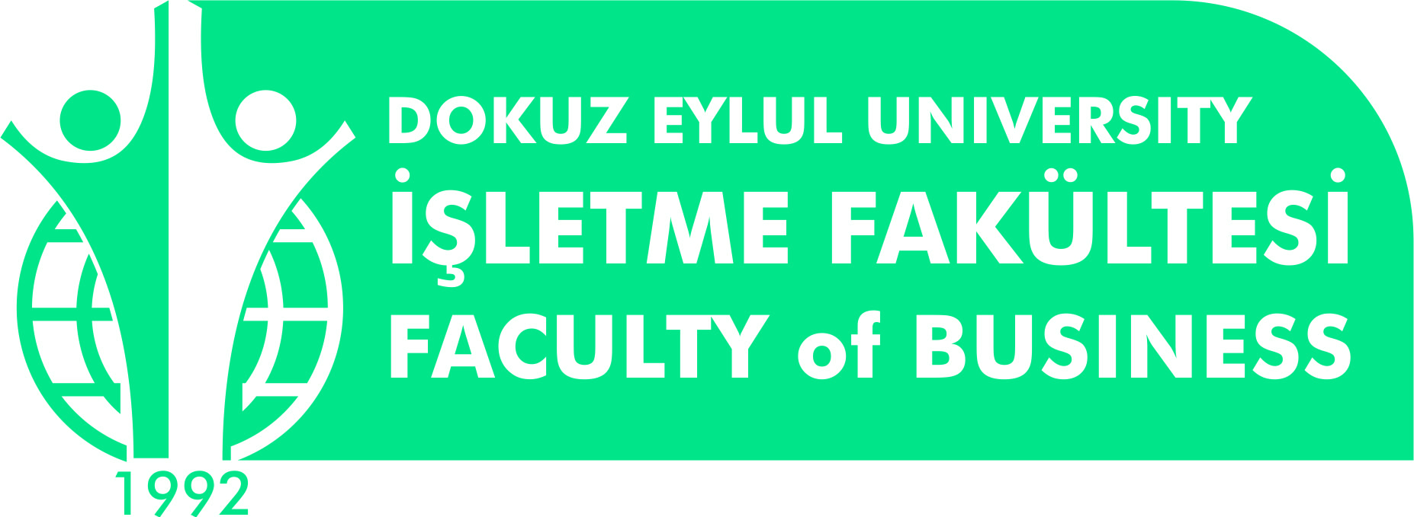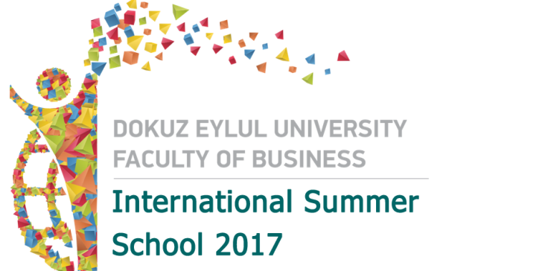

3rd International Summer School

Dear Colleague,
Dear Partner,

This is to inform you about 3rd International Summer School to be held between 12-23 June 2017, in Izmir, TURKEY.
“International Summer School” Program is designed to provide the young intellectuals of tomorrow, with a summer course consisting of lectures, discussions and workshops that tackle the key issues faced by global leaders of the future. Student (s) will explore
the relationship between economic, financial, managerial ,political and social connections to maintain a global sustainable business system.

At a glance
12-23 June 2017  2-weeks of course  5 ECTS for each course  600 Euro ( covers course fee, excursions, company visits, accommodation, breakfast, lunch, farewell dinner and international evening )  Open to undergraduate & graduate students  Study and explore İzmir | Explore TURKEY! Make a sunny holiday  2 Coach excursions included  2 Company visits  Challenging area of International Business and Economics  Attendance Certificate& Transcript  Visit to Ancient City Ephesus

We would like to expand well-developed network with your institute, and would be happy to welcome your students. Therefore, we would appreciate if you could circulate this call on your students and staff mail groups. Should you please provide detailed information from addresses below and do not hesitate to contact us.

http://deuzem.deu.edu.tr/fbsummer/
Application and payment deadline : 15th of May 2017
International Summer School of DEU Faculty of Business

Prof. Dr. Canan Madran Işınsu ATALAY, MSc.
Summer School Coordinator International Office Administrative Coordinator
canan.madran@deu.edu.tr isinsu.atalay@deu.edu.tr, iso@deu.edu.tr

